# Rectifier Diode

Table Rectifier Diode component selection

|  |  |  |  |  |  |
| --- | --- | --- | --- | --- | --- |
| Rectifier Diode | Reverse Voltage  (V) | Forward Current(mean) (A) | Forward Current(peak)  (A) | Forward Voltage  (V) | Cost |
| S1G(Single) | 400 | 1 | 10 | 1.1 | 6*0.04284$=0.257$ |
| 3GBJ3516-BP (Three Phase) | 1600 | 35 | 400 | 1.1 | 0.874 $ |
| DLA5P800UC-TRL(Array) | 800 | 5 | 70 | 1.18 | 0.458*3=1.374$ |
| Simulation | 250 | 0.2 | 1.2 | 0.7 |  |

In the market research on diodes, array diodes and three phase rectifiers were investigated. When the single diode cost and array diode cost were compared, it was understood that the surge current values of the array diodes were not sufficient in the cost range of six single diode. Also, voltage and current ratings of single phase and three phase array diodes was too large, therefore thermal calculation cannot be made without using heatsink in datasheets. Finally, the diode rectifier is constructed with single diodes. The separate usage has advantages in terms of cost and fault. The production of single diodes can be manufactured in huge amounts, which can provide them with low cost. Also, single diodes can be replaced easily. The important parameters are breakdown voltage and forward current ratings. There is no need to fast diodes because the electrical frequency of generator cannot excess the 60Hz due to small pole-pair number.

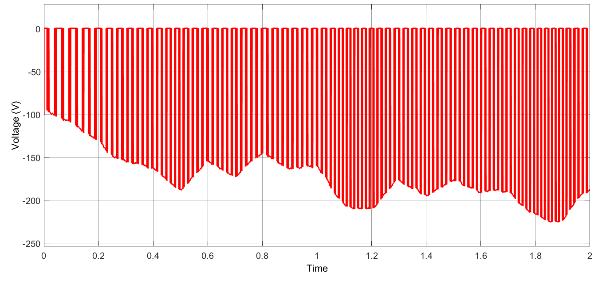

*Figure Voltage Waveform of Rectifier Diodes*

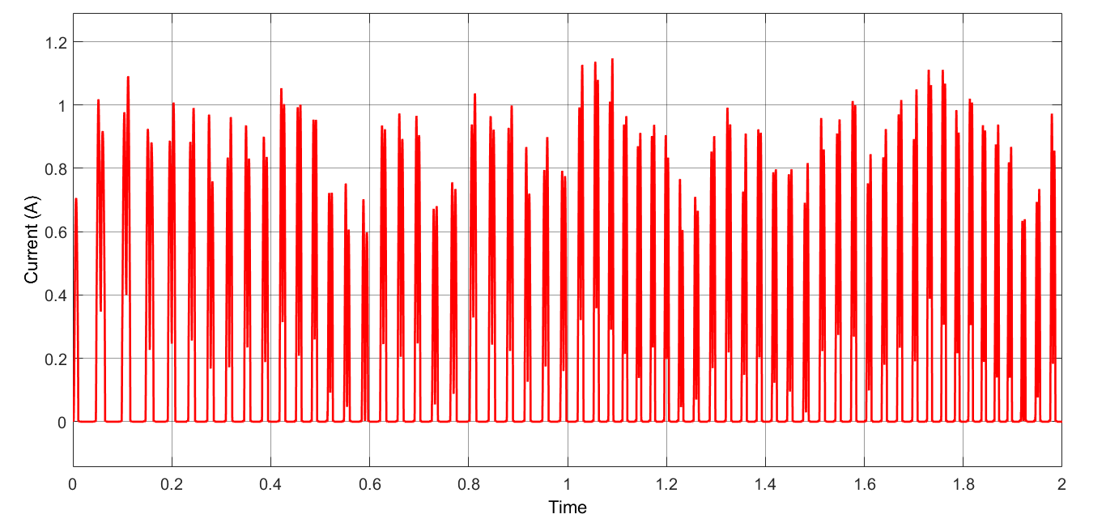

*Figure Current Waveform of Rectifier Diodes*

# DC Link Capacitor

Table DC Link Capacitor component selection

|  |  |  |  |  |  |
| --- | --- | --- | --- | --- | --- |
| Rectifier Capacitor | Capacitance (ɥF) | Voltage Rating (V) | Cost ($) | Height (mm) | Rated Ripple Current (mA) |
| MAL219856569E3-ND | 56 | 400 | 3.91 | 27 | 720 |
| 450VXS390MEFC30X50 | 390 | 450 | 2.07(200 pieces) | 52 | 2110 |
| 400HXG470MEFC30X50-ND | 470 | 400 | 2.67(200 pieces) | 52 | 3040 |
| 400USG470MEFC25X50 | 470 | 400 | 2.69 (200 pieces) | 52 | 2390 |
| 380LX471M350A032 | 470 | 350 | 2.47(560 pieces) | 37 | 2400 |

The 56 ɥF capacitor is sufficient for the design, so we chose the first capacitor in the table x before. Subsequently, cheaper capacitors with higher capacitance are found in the market. When choosing capacitors, we paid attention to voltage ratings and current ripple values in steady state analysis of simulations. When we made a comparison in terms of price and size, we decided to choose the capacitor at the bottom of the table x.

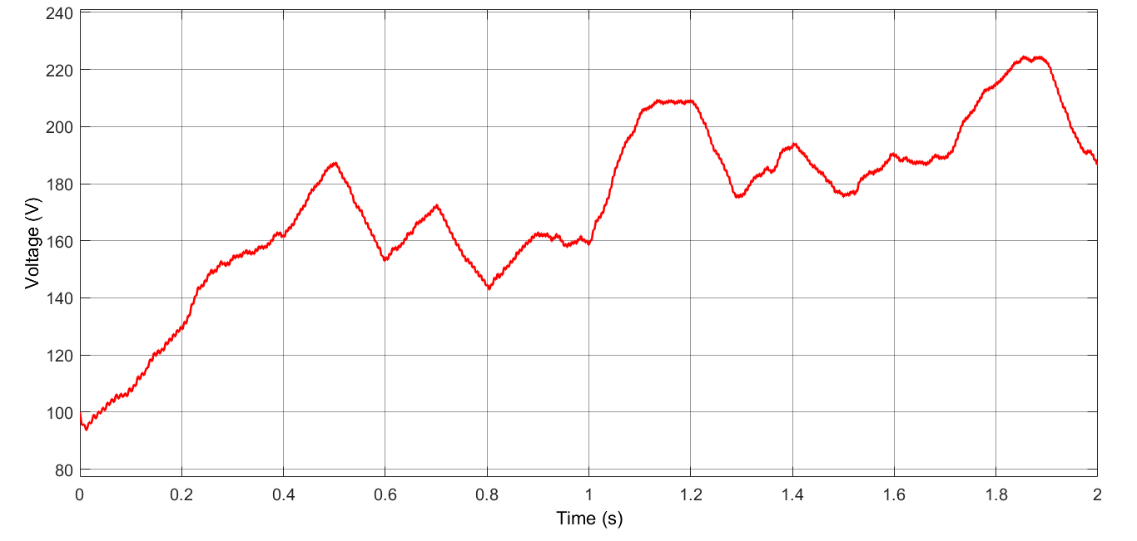

*Figure Voltage Waveform of DC Link Capacitor*

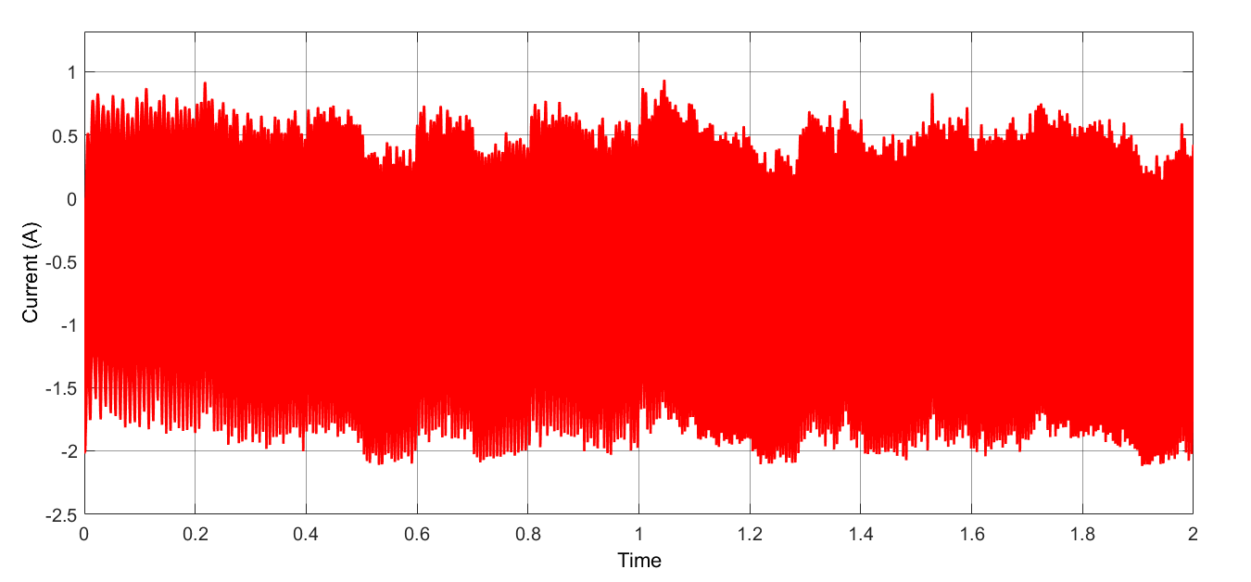

*Figure Current Waveform of Rectifier Diodes*

# Buck Converter Capacitor

Table DC Link Capacitor component selection

|  |  |  |  |  |  |
| --- | --- | --- | --- | --- | --- |
| Buck Converter Capacitor | Capacitance (ɥF) | Voltage Rating (V) | Cost ($) | Size (mm) | ESR (mΩ) |
| ESC686M035AE3AA | 68 | 35 | 3*0.07232 | 22 (diameter) | 220 |
| GRM188R6YA475KE15D | 4.7 | 35 | 0.11537 | 1.6 (length) | 100 |

Capacitor voltage will not be higher than 26 V, because battery is tested before. Also, ripple current of the capacitor is 50 milli amperes, it should be taken into consideration. One of the most important factors in capacitor selection is the ESR which value. An upper bound have been set as 0.25 due to the rating between output voltage and current ripple values. It can be also seen from the Equation (6) that the required capacitor value increases as the ESR value chosen to be close to 0.25. Therefore, capacitors with around 0.2 Ω ESR values tried to be compared according to their capacitance values and most importantly voltage ratings as capacitor should be able to charge at least until the value of converter output. Instead of using only one capacitor, we reduced the ESR value by using three capacitors. In this way, ripple voltage values are reduced without taking up too much space. When we compare size, cost and ESR values, second capacitor is chosen.

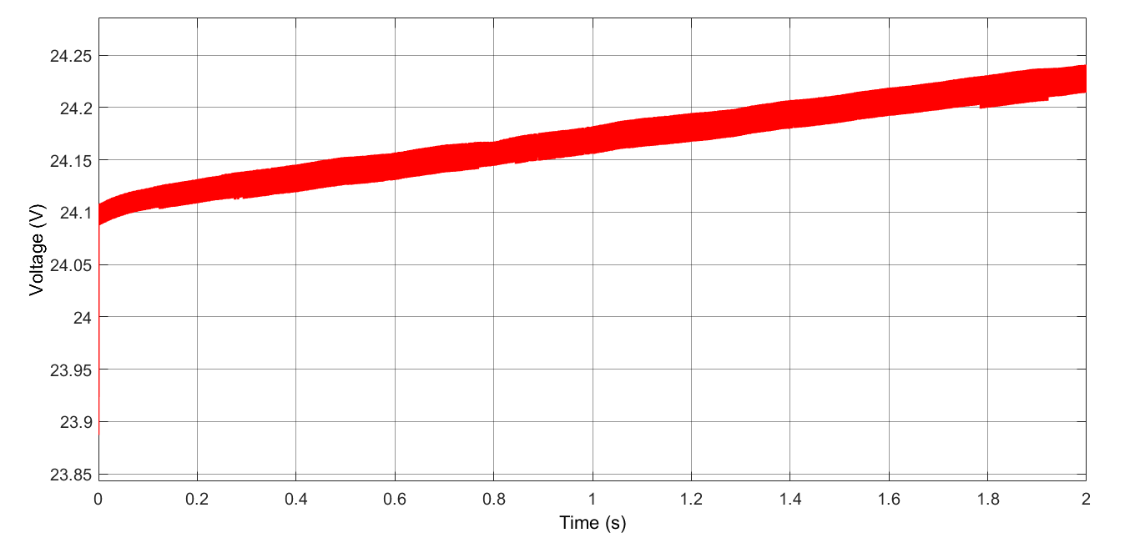

*Figure Voltage Waveform of Converter Capacitor*

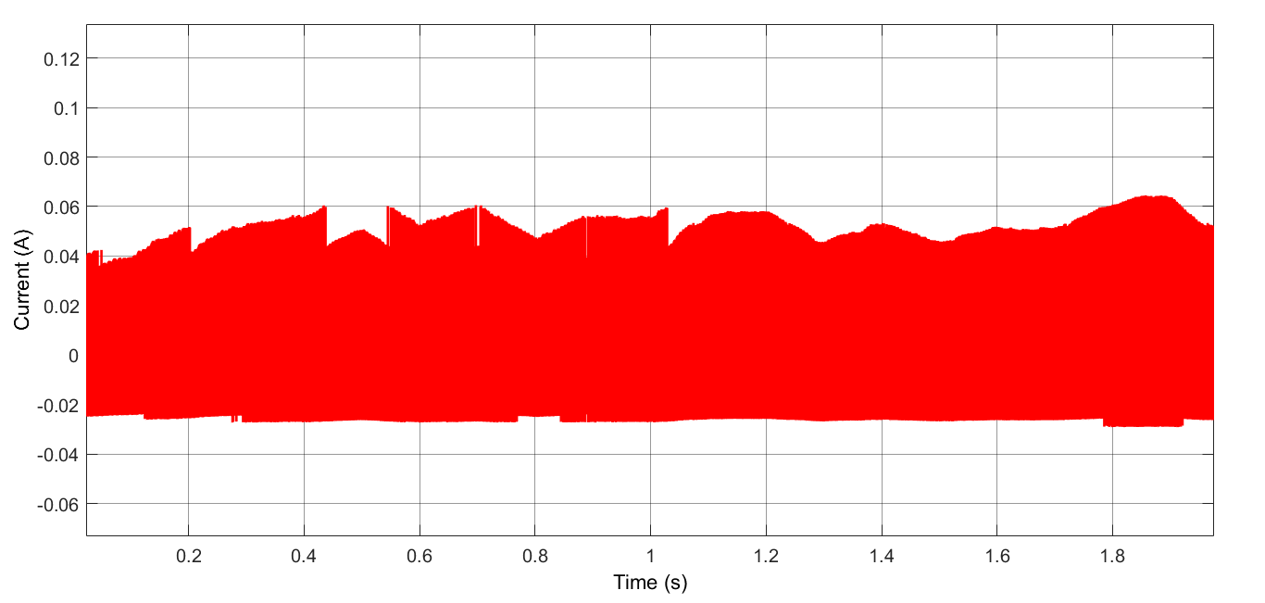

*Figure Current Waveform of Converter Capacitor*

# Buck Converter Diode

Table Diode component selection

|  |  |  |  |  |  |
| --- | --- | --- | --- | --- | --- |
| Diode (Buck Conv) | VRRM (V) | IF(AV) (A) | VFD (V) | Qrr (nC) | Cost $ |
| ES3G | 400 | 3 | 1.1 | 50 | 0.18 |
| UF5404 E3/54 | 400 | 3 | 1.0 | 8 | 0.224 |

As the diode will guide the converter during the OFF times of the MOSFET, which will be about %90 due to the input and output voltage rate of the rectifier, it choosed to be super fast rectifier diode, which lowers the switching losses due to its fast reverse recovery time. While choosing diode, it should be also considered that the voltage rating accros it will be approximately around 400 V coming from the rectifier voltage.

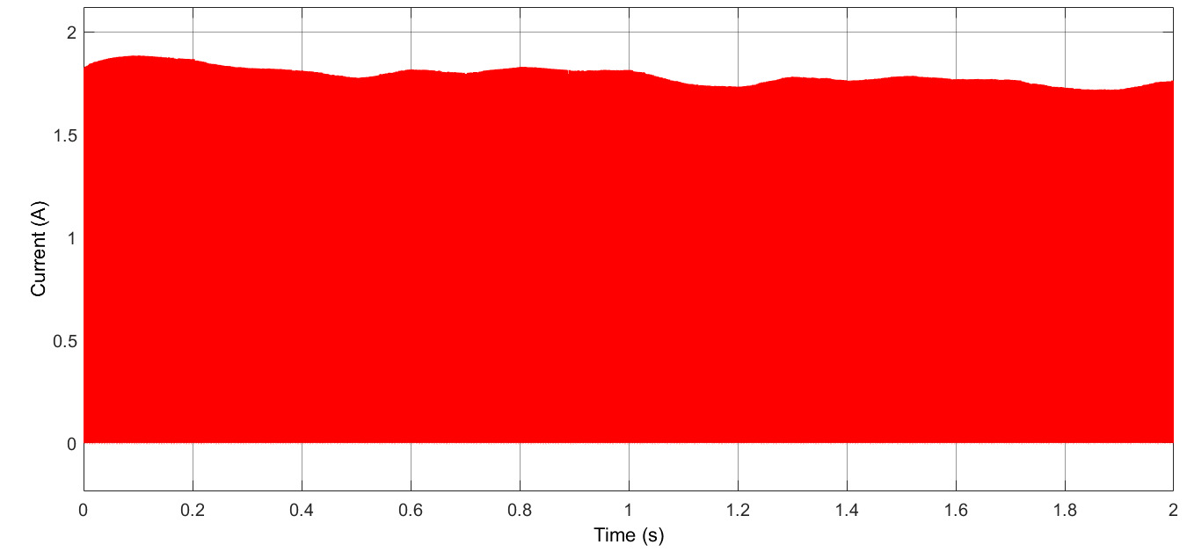

*Figure Current Waveform of Freewheeling Diodes*

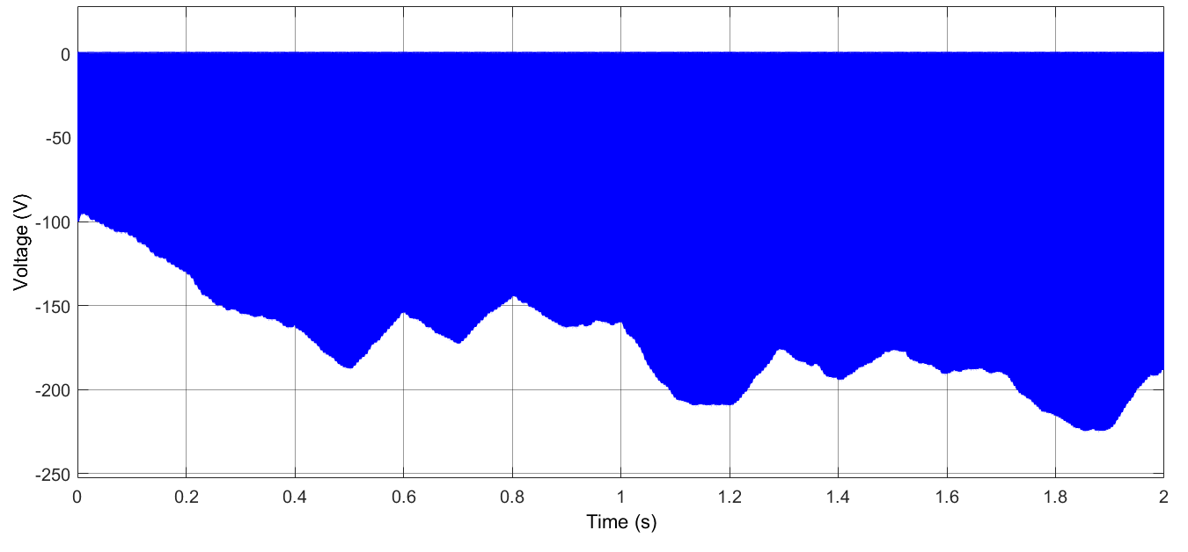

*Figure Voltage Waveform of Freewheeling Diodes*

# Buck Converter Inductor

Table 5 Inductor component selection

|  |  |  |  |  |
| --- | --- | --- | --- | --- |
|  | Inductance (mH) | Current Rating (A) | Saturation Current | Price ($) |
| 1140-272K-RC | 2.7 | 2.2 | 3.9 | 9.56 |
| AIRD-03-152K | 1.5 | 2 | 3.4 | 5.52 |
| PowerGuide Inductor | 1.5 | 3 | 4.06 | 3.23 $ |

The main point while choosing an inductor is its current ratings in addition to inductance. Even though, 2A average values expected on top of the inductor, it was observed in … that the current value on the inductor can reach peak values of 2.15 A. Therefore, special attention has been given to the saturation currents during the selection of the inductor. The inductor models which use ferrite core as magnetic material have been preferred due to their ability to operate at higher frequencies and allowing higher inductor values with smaller size. Two different inductor values have been compared to determine the advantages and disadvantages each have. Even though, high inductance value can decrease the output current ripple even further, considering the price of 1140-272K-RC, choosing AIRD-03-152K evaluated to be more appropriate. When the %10 tolerance of the AIRD-03-152K also included, it can be said that this inductor will not cause any problem in providing the required inductance value for the converter to supply current within the previously specified ripple current range. After making these comparisons, we decided to design an inductor for making cheaper and learning purposes, and we used our own inductor in the project.

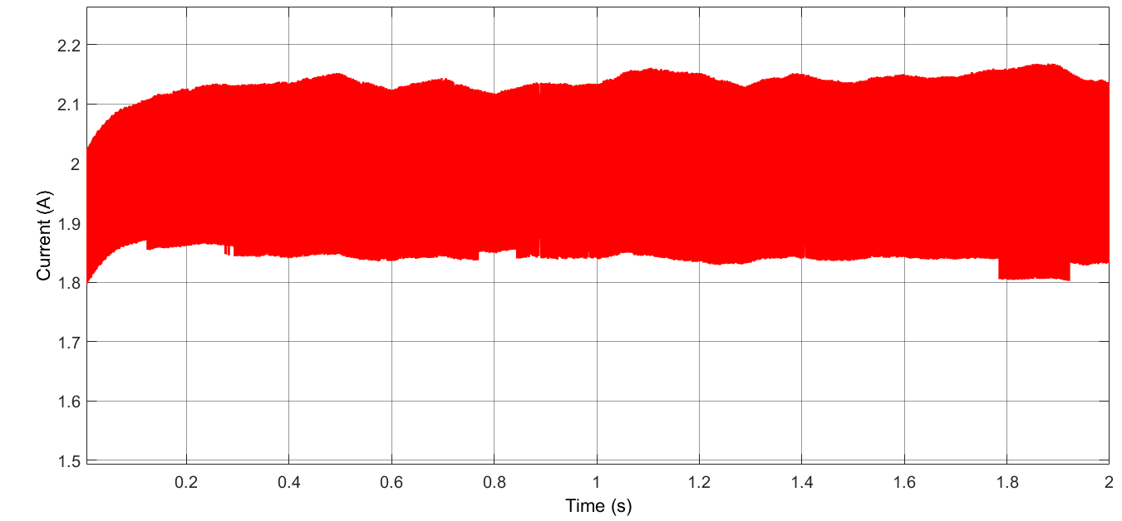

*Figure Current Waveform of Inductor*

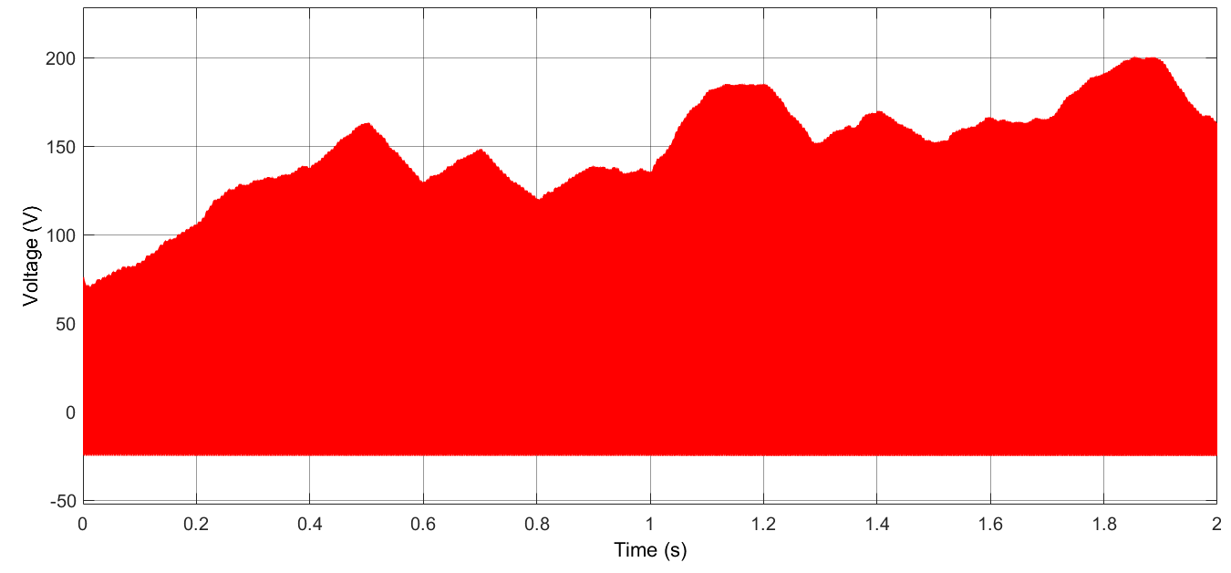

*Figure Voltage Waveform of Inductor*

# Buck Converter Switch

Table 8 MOSFET component selection

|  |  |  |  |  |
| --- | --- | --- | --- | --- |
|  | VDS (V) | RDS (on) (Ω) | ID (A) | Price($) |
| SPN04N60S5 | 600 | 0.95 | 0.8 | Non-stock |
| IPU60R1K4C6 | 650 | 1.4 | 3.2 | 0.33 |
| IPS60R1K0PFD7S | 650 | 1.0 | 4.7 | 0.31 |
| IPD50R650CEAUMA1 | 500 | 0.65 | 9 | 0.31 |

The most important parameter while choosing a MOSFET for switching applications is its Ron resistance to decrease conduction loss. Different type of MOSFTET have been compared and IPD50R650CEAUMA1 have been found to be more suitable to use in the converter, considering its resistance and price.

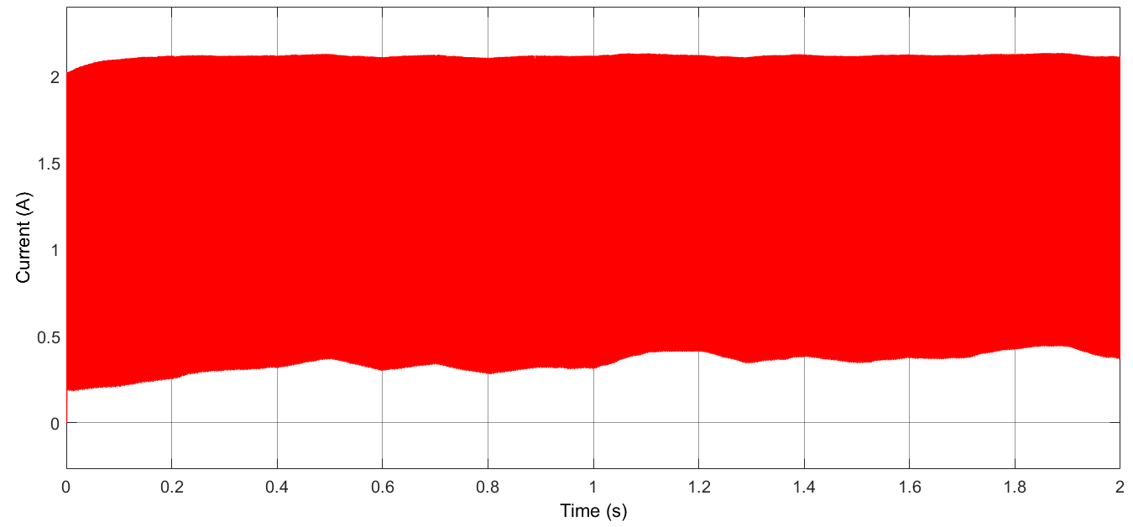

*Figure Current Waveform of MOSFET*

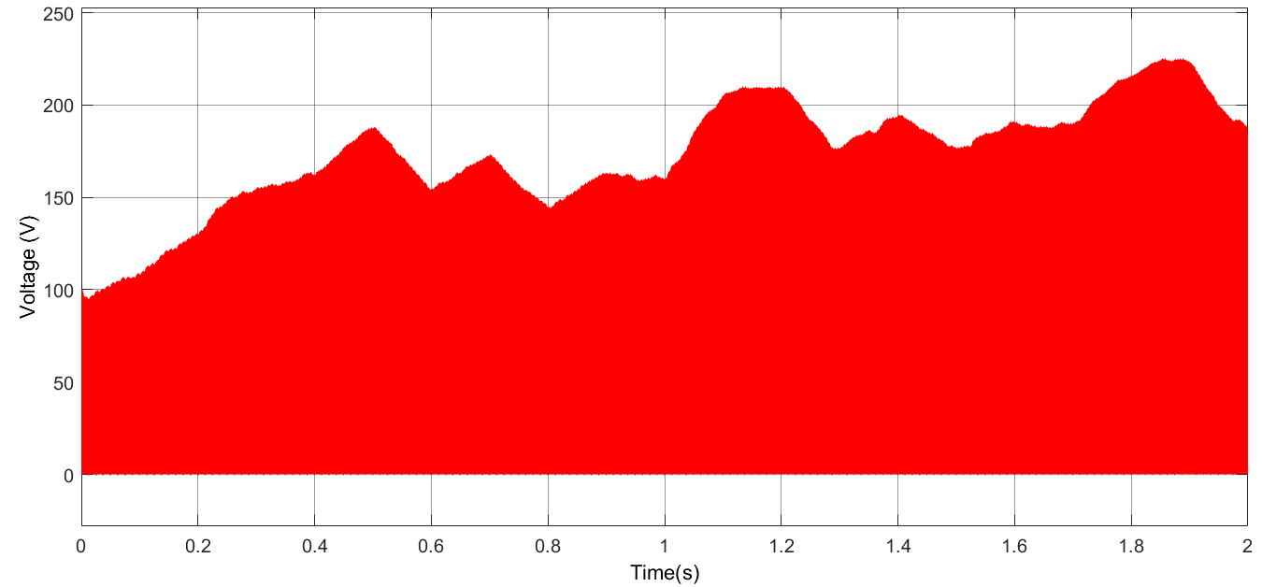

*Figure Voltage Waveform of MOSFET*

# Controller

Table 9 Controller component selection

|  |  |  |  |
| --- | --- | --- | --- |
| Controller | VIN (V) | Min on Time (ns) | Cost |
| HV9961LG-G | 8-450 | 430 | 1.19$ |

In market research about controller, we could not find the controllers containing its MOSFET with an input voltage above 150 V, so we decided to buy this controller whose MOSFET is connected externally. Thanks to this controller, gate driver is not needed.

# Controller Resistors

Table 9 Controller Resistors selection

|  |  |  |  |
| --- | --- | --- | --- |
| Resistors | Resistance (Ω) | Power (W) | Tolerance (%) |
| VDD Resistor  RK73B2ATTD204G | 200 k | 0.25 | 2 |
| Frequency Resistor  RK73H2ETTD4023F | 402 k | 0.5 | 1 |
| Current Sense Resistor  CSRN2010JKR130 | 0.13 | 1 | 5 |

Required resistance are calculated datasheets of the controller, and resistors are chosen by taking into consideration rated power values. Shunt resistor is selected from current sense resistors.

# Battery Diode

Table 9 Battery component selection

|  |  |  |  |  |  |
| --- | --- | --- | --- | --- | --- |
| Battery Diode | VRRM | IF(AV) | VFD | Qrr | Cost |
| PMEG3030EP,115 | 30V | 3A | 0.36 | 0 | 0.12$ |

For this part of the topology, Schottky diode is chosen because Schottky diodes have low forward voltages and their losses mostly are due to reverse leakage currents. The diode will be in on mode in normal conditions; therefore, losses will be less with respect to other types of diode.

# Controller Capacitor

Table DC Link Capacitor component selection

|  |  |  |  |  |
| --- | --- | --- | --- | --- |
| VDD Capacitor | Capacitance (ɥF) | Voltage Rating (V) | Cost ($) | Size (mm) |
| C2012X7R1C225K125AB | 2.2 | 16 | 0.045 | 2*1.25 |

SMD capacitors are investigated for the controller parts because SMD capacitors size is lower than THT capacitors

# Bills of Materials

While we were choosing components, we made sure that each product had at least 1000 sales in order to be included in the cheapest design bonus. Rectifier Capacitor is sold in packages of 560. In addition, the controller is sold in packages of 100. Unfortunately, there is no cheaper alternative sold in 1000 packages. Unfortunately, we could not find a cheaper one with more sales. Also, Buck Converter Diode is sold in packages of 500 and 1400. When calculating, 1400 packages are taken into consideration. If the package of 500 is taken into account, the unit price is $ 0.29286, and the cost will be $ 0.05482 more. Since we designed the Inductor, we purchased 1000 Toroid and it is enough to buy 23 packages of cables for 1000 inductors. Also, we have not included the cost of shipping charges when calculating cost of PCB, if PBCs are able to be ordered by FedEx for Turkey and its cost is $ 98. In this case, the unit price will increase by $ 0.098. In the design, extra diode is added to topology as an extra feature so that there is no energy loss from the battery when the wind turbine is not rotating and there is no reverse load on the system. If battery diode is not used, the unit cost should decrease by $ 0.12193.

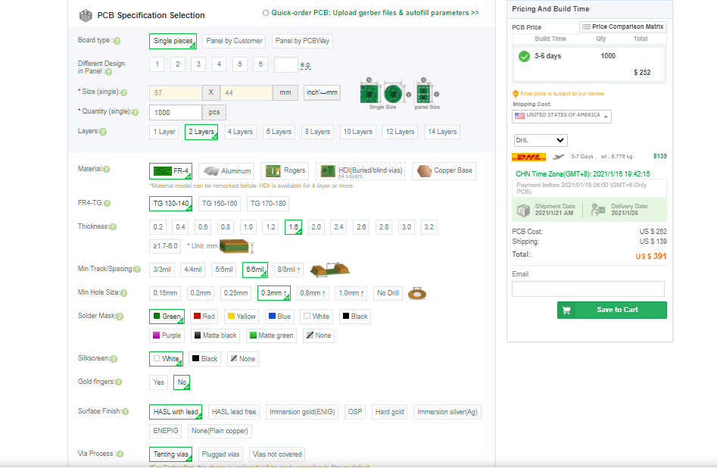

*Figure PCB Cost Calculations*

|  |  |  |  |  |  |  |  |
| --- | --- | --- | --- | --- | --- | --- | --- |
| Index | Component Name | Part Number | Manufacturer Part Number | Description | Package Quantity | Unit Price | Unit Cost |
| 1 | Rectifier Diode | S1GFSCT-ND | S1G | DIODE GEN PURP 400V 1A SMA | 1000 | 0.04284 | 0.25704 |
| 2 | DC-Link Capacitor | 380LX471M350A032-ND | 380LX471M350A032 | CAP ALUM 470UF 20% 350V SNAP | 560 | 2.46961 | 2.46961 |
| 3 | Buck Converter Diode | UF5404-E3/54GITR-ND | UF5404-E3/54 | DIODE GEN PURP 400V 3A DO201AD | 1400 | 0.22456 | 0.22456 |
| 4 | Inductor Core | T106-3 Micro metals Iron Powder Toroid |  | Used for high Q applications below 1MHz. | 1000 | 1.5 | 1.5 |
| 5 | Inductor Cable | 2328-22BCW1000-ND | 22BCW1000 | WIRE BUS BAR 22AWG 1000 | 23 | 1.73236 | 1.73236 |
| 6 | Buck Converter Capacitor | 490-7205-1-ND | GRM188R6YA475KE15D | CAP CER 4.7UF 35V X5R 0603 | 1000 | 0.11537 | 0.34611 |
| 7 | Buck Converter MOSFET | 448-IPD50R650CEAUMA1CT-ND | IPD50R650CEAUMA1 | CONSUMER | 1000 | 0.31024 | 0.31024 |
| 8 | Controller | HV9961LG-GCT-ND | HV9961LG-G | IC LED DRIVER CTRLR DIM 8SOIC | 100 | 1.19 | 1.19 |
| 9 | Controller Resistor 1 | 2019-RK73B2ATTD204GCT-ND | RK73B2ATTD204G | RES 200K OHM 2% 1/4W 0805 | 1000 | 0.01179 | 0.01179 |
| 10 | Controller Resistor 2 | 2019-RK73H2ETTD4023FCT-ND | RK73H2ETTD4023F | RES 402K OHM 1% 1/2W 1210 | 1000 | 0.02671 | 0.02671 |
| 11 | Controller Resistor 3 | CSRN2010JKR130-ND | CSRN2010JKR130 | RES 0.13 OHM 5% 1W 2010 | 1000 | 0.084 | 0.084 |
| 12 | Controller Capacitor | 445-1420-1-ND | C2012X7R1C225K125AB | CAP CER 2.2UF 16V X7R 0805 | 1000 | 0.04554 | 0.04554 |
| 13 | Battery Diode | 1727-5324-1-ND | PMEG3030EP,115 | DIODE SCHOTTKY 30V 3A CFP5 | 1000 | 0.12193 | 0.12193 |
| 14 | PCB |  |  | 2 LAYER 57*44 mm^2 | 1000 | 0.252 | 0.252 |
|  | Total Cost |  |  |  |  |  | 8.57189 |